Name: Jayaadithya Yadav Roll No:22R21A1220

Section:It-A

**Webpage using flex**

**HTML Code:**

<!DOCTYPE html>

<html lang="en">

<head>

    <meta charset="UTF-8">

    <meta name="viewport" content="width=device-width, initial-scale=1.0">

    <link rel="stylesheet" href="iphone.css">

    <title>Document</title>

</head>

<body class="compare">

    <h2 align="center"><b><u>iphone 16</u> Models</b></h2><h3 align="right"><b>Jayaadithya yadav <br>22R21A1220</b></h3><br><br>

    <div class="iphone">

    <div class="iphone16">

        <h4 align="center">iphone 16</h4>

        <img src="iphone 16 .png" alt=" iphone 16"><br><br><br><a href="https://www.apple.com/iphone-16/">click here to visit iphone 16</a><br>

        <p align="justify">iPhone 16 is built for Apple Intelligence, the personal intelligence system that helps you write,

             express yourself and get things done effortlessly.

            With groundbreaking privacy protections, it gives you peace of mind that no one else can access your data — not even Apple.</p>

    </div>   <div class="iphone16pro">

        <h4 align="center">iphone 16 pro</h4>

        <img src="iphone 16 pro.png" alt="iphone 16 pro"><br><br><a href="https://www.apple.com/in/iphone-16-pro/">click here to visit iphone 16 pro</a><br>

        <p align="justify">iPhone 16 Pro features a Grade 5 titanium design with a new, refined micro-blasted finish.

            Titanium has one of the highest strength-to-weight ratios of any metal, making these models incredibly strong and impressively light.

            iPhone 16 Pro comes in four stunning colours — including new Desert Titanium.</p>

    </div>

    <div class="iphone16promax">

        <h4 align="center">iphone 16 pro max</h4>

    <img src="iphone 16 pro max.png" alt="iphone 16 pro max"><br><a href="https://www.apple.com/in/iphone-16-pro/">click here to visit iphone 16 pro max</a><br>

        <p align="justify">iPhone 16 Pro max features a Grade 5 titanium design with a new, refined micro-blasted finish.

            Titanium has one of the highest strength-to-weight ratios of any metal, making these models incredibly strong and impressively light.

             iPhone 16 Pro max comes in four stunning colours — including new Desert Titanium.</p>

    </div>

    </div>

</body>

</html>

**CSS Code:**

.iphone{

    display: flex;

    justify-content: center;

    align-content: center;

    border: 5px;

padding: 5px;

border-color: black;

}.features,.iphone16,.iphone16pro,.iphone16promax

{align-items: center; text-align: center; background-color:white;

font-size: 25px;

border: 2px solid black;

padding: 5px:}

**OUTPUT:**

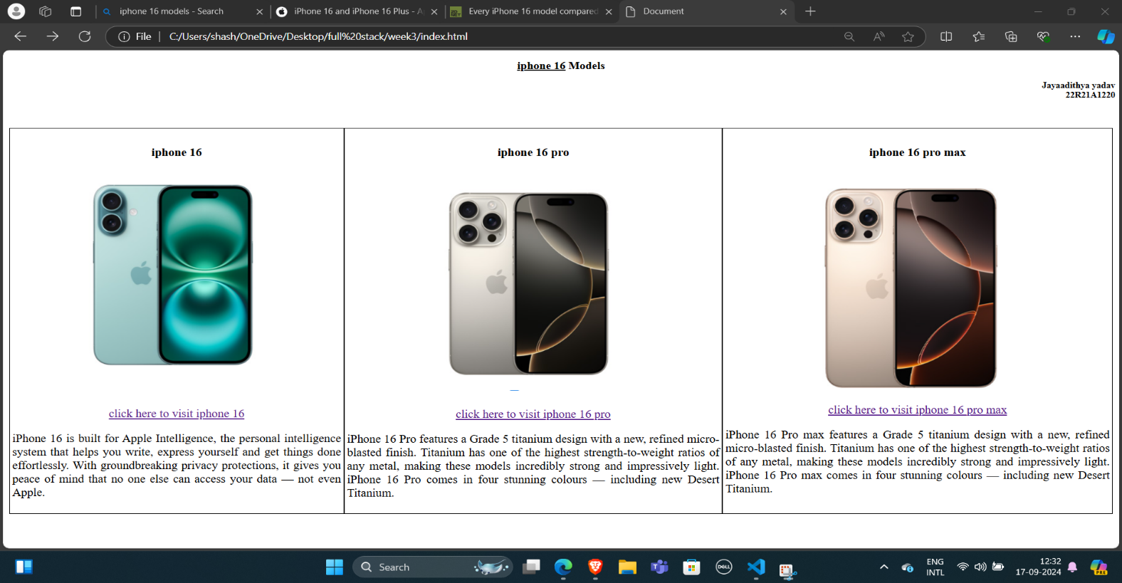

**Webpage using Grid:**

**HTML Code:**

<!DOCTYPE html>

<html lang="en">

<head>

    <meta charset="UTF-8">

    <meta name="viewport" content="width=device-width, initial-scale=1.0">

    <link rel="stylesheet" href="iphone.css">

    <title>Document</title>

</head>

<body class="compare">

    <h2 align="center"><b><u>iPhone 16</u> Models</b></h2>

    <h3 align="right"><b>Jayaadithya Yadav <br>22R21A1220</b></h3>

    <br><br>

    <div class="iphone">

        <div class="features">Features</div>

        <div class="iphone16">

            <h4 align="center">iPhone 16</h4>

            <img src="iphone 16 .png" alt="iPhone 16">

            <br><br><br>

            <a href="https://www.apple.com/iphone-16/">Click here to visit iPhone 16</a>

            <br>

            <p align="justify">iPhone 16 is built for Apple Intelligence, the personal intelligence system that

                helps you write, express yourself, and get things done effortlessly.

                With groundbreaking privacy protections, it gives you peace of mind that no one else can access your data — not even Apple.</p>

        </div>

        <div class="iphone16pro">

            <h4 align="center">iPhone 16 Pro</h4>

            <img src="iphone 16 pro.png" alt="iPhone 16 Pro">

            <br><br>

            <a href="https://www.apple.com/in/iphone-16-pro/">Click here to visit iPhone 16 Pro</a>

 <br>

  <p align="justify">iPhone 16 Pro features a Grade 5 titanium design with a new, refined micro-blasted finish.

     Titanium has one of the highest strength-to-weight ratios of any metal, making these models

      incredibly strong and impressively light. iPhone 16 Pro comes in four stunning colours — including new Desert Titanium.</p>

 </div>

 <div class="iphone16promax">

 <h4 align="center">iPhone 16 Pro Max</h4>

 <img src="iphone 16 pro max.png" alt="iPhone 16 Pro Max"><br>

 <a href="https://www.apple.com/in/iphone-16-pro/">Click here to visit iPhone 16 Pro Max</a>

 <br>

 <p align="justify">iPhone 16 Pro Max features a Grade 5

            titanium design with a new, refined micro-blasted finish.

                  Titanium has one of the highest strength-to-weight ratios of any metal, making these models incredibly strong and impressively light. iPhone 16 Pro Max comes in four stunning colours — including new Desert Titanium.</p>

</div>

<div class="container">Price</div><div class="container">$799</div>

 <div class="container">$999</div> <div class="container">$1,199</div> <div class="container">Display</div><div class="container">6.1-in Super Retina XDR OLED</div>

<div class="container">6.3-in Super Retina XDR OLED</div><div class="container">6.9-in Super Retina XDR OLED</div>

<div class="container">Processor</div><div class="container">A18</div><div class="container">Apple A18 Pro</div>

<div class="container">Apple A18 Pro</div><div class="container">RAM</div><div class="container">8 GB</div>

<div class="container">8 GB</div><div class="container">8 GB</div><div class="container">Storage</div><div class="container">128GB, 256GB, 512GB</div>

<div class="container">128GB, 256GB, 512GB, 1TB</div><div class="container">256GB, 512GB, 1TB</div><div class="container">Resolution</div>

<div class="container">2446 x 1179 pixel</div><div class="container">2622 x 1290 pixel</div><div class="container">2868 x 1320 pixel</div>

<div class="container">Camera</div><div class="container">48 MP Fusion | 12MP UW</div><div class="container">48MP Wide | 12MP Tele 5x | 48MP UW | 12MP Selfie</div><div class="container">48MP Wide | 12MP Tele 5x | 48MP UW | 12MP Selfie</div>

</body>

</html>

**CSS Code:**

.iphone{

  display: grid;

  text-align: center;

  grid-template-columns: repeat(4, auto);

  gap: 5px;

border: 5px ;

padding: 5px;

}

.features,.iphone16,.iphone16pro,.iphone16promax,.container{

align-items: center;

 text-align: center;

background-color:white;

font-size: 25px;

border: 2px solid black;

padding: 5px;

}

**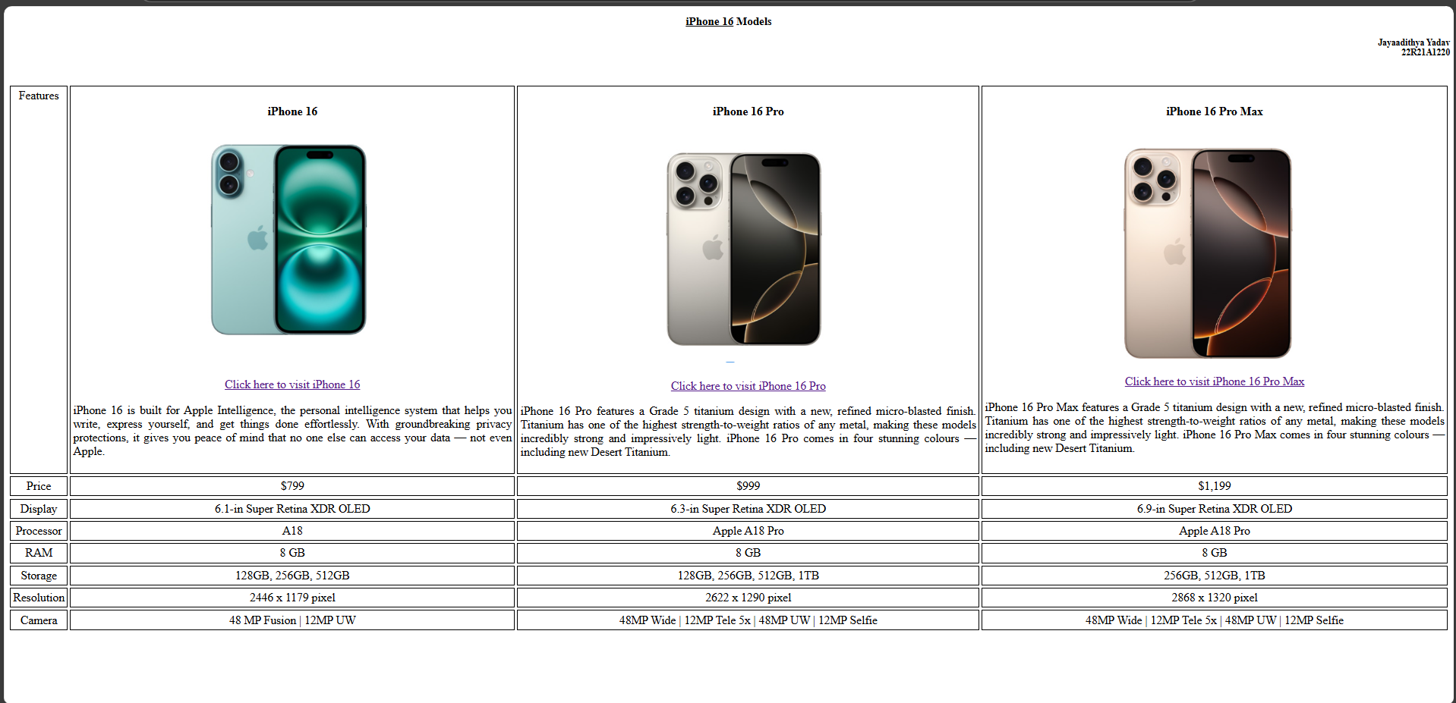  
Positions IN CSS:**

**HTML:**

<!DOCTYPE html>

<html lang="en">

<head>

    <meta charset="UTF-8">

    <meta name="viewport" content="width=device-width, initial-scale=1.0">

    <title>Document</title>

    <link rel="stylesheet" href="position.css">

</head>

<body>

    <div class="static" style="background-color: rgb(22, 196, 226);">this is static position</div>

    <div class="relative" style="background-color: antiquewhite;">this is relative position</div>

    <div class="fixed" style="background-color: coral;">this is fixed</div>

    <div class="absolute" style="background-color: aqua;">this is absolute</div>

    <div class="sticky" style="background-color: cornsilk;">this is sticky</div>

</body>

</html>  
**CSS:**

body{

  background: url(1.webp) no-repeat fixed center;

  background-size: cover;

}

.static{

   height: 100px;

   width: 1000px;

   border: 5px solid black;

   position: static;

}

.relative{

    height: 100px;

    width: 1000px;

    border: 5px solid red;

    position: relative;

    left: 90px;

    bottom: 10px;

}

.fixed{

    height: 100px;

    width: 1000px;

    border: 5px solid green;

    position: fixed;

   right: 0;

   bottom: 180px;

}

.absolute{

    height: 100px;

    width: 1000px;

    border: 5px solid orange;

    position: absolute;

    left: 60;

    bottom: 10px;

}

.sticky{

    height: 100px;

    width: 1000px;

    border: 5px solid greenyellow;

    position: sticky;

    left: 60;

    bottom: 10px;

}

